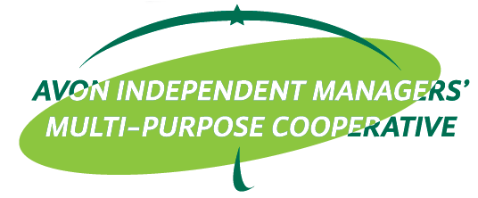

**ACTIVITY DESIGN**

ACTIVITY :  PMES/MOM

LOCATION : Avon ______

DATE/TIME : _____________

**OBJECTIVES:**

* + To refresh and update AIM-MPC members
  + To recruit new members

**PARTICIPANTS:**

* ___________________________________

**TRAINER/S:**

* ___________________________________

**BUDGETARY REQUIREMENTS:**

|  |  |
| --- | --- |
| **Particulars** | **Budget** |
| Meal for Attendees: SnackP100.00/pax Lunch P175.00 |  |
| Trainer’s meal: P100.00/pax (snack) |  |
| Trainer’s meal: P175.00/pax (lunch) |  |
| Trainer’s fee (P3,000.00) |  |  |
| MBC Allowance (P1,000.00) |  |
| Transportation Allowance (back & forth) (trainer only) |  |
| Contingency |  |
| **TOTAL** |  |

Prepared by: Recommending Approval:

**_____________ REYNALDO O. ACOSTA**

EdCom Trainer EdCom Chairperson

Approved by: Noted by:

**PERLITA A. BALLETA JULIUS S. CARBALLO**

General Treasurer BOD Chairperson